Assignment 2: A* Algorithm

CODE:
<!DOCTYPE html>
<html>
<head>
<title>A* Algorithm</title>
<style>
.grid { display: grid; grid-template-columns: repeat(5, 50px); gap: 2px; }
.cell { width: 50px; height: 50px; background: #eee; display: flex; align-items: center; justify-content: center; font-weight: bold; }
.start { background: #4CAF50; }
.end { background: #f44336; }
.wall { background: #333; }
.path { background: #9C27B0; color: white; }
.visited { background: #FFD54F; }
button { margin: 20px; padding: 10px 20px; font-size: 16px; }
</style>
</head>
<body>
<h2>A* Pathfinding</h2>
<button onclick="runAStar()">Run A*</button>
<div class="grid" id="grid"></div>

<script>
const grid = [
[0, 0, 0, 0, 0],
[0, 1, 1, 0, 0],
[0, 0, 0, 1, 0],
[0, 1, 0, 0, 0],
[0, 0, 0, 0, 0]
]; // 0 = empty, 1 = wall

const start = {x: 0, y: 0};
const end = {x: 4, y: 4};

// Draw grid
function drawGrid() {
const container = document.getElementById('grid');
container.innerHTML = '';
for (let i = 0; i < 5; i++) {
for (let j = 0; j < 5; j++) {
const cell = document.createElement('div');
cell.className = 'cell';
cell.id = `c${i}${j}`;
if (i === start.x && j === start.y) cell.classList.add('start');
else if (i === end.x && j === end.y) cell.classList.add('end');
else if (grid[i][j] === 1) cell.classList.add('wall');
container.appendChild(cell);
}
}
}

// Heuristic (Manhattan distance)
function h(a, b) {
return Math.abs(a.x - b.x) + Math.abs(a.y - b.y);
}

// A* Algorithm
async function runAStar() {
drawGrid();
console.clear();
console.log("=== A* Algorithm ===");

let open = [{x: start.x, y: start.y, g: 0, f: 0, parent: null}];
let closed = [];

while (open.length > 0) {
// Get node with lowest f
open.sort((a, b) => a.f - b.f);
let current = open.shift();

console.log(`Visiting (${current.x}, ${current.y}) | f=${current.f}`);

// Goal reached
if (current.x === end.x && current.y === end.y) {
console.log("\n=== Path Found ===");
let path = [];
let node = current;
while (node) {
path.unshift(`(${node.x},${node.y})`);
if (node.parent) document.getElementById(`c${node.x}${node.y}`).classList.add('path');
node = node.parent;
}
console.log("Path: " + path.join(" → "));
console.log("Steps: " + (path.length - 1));
return;
}

closed.push(current);
document.getElementById(`c${current.x}${current.y}`).classList.add('visited');
await new Promise(r => setTimeout(r, 300));

// Check neighbors (up, down, left, right)
const dirs = [[0,1], [1,0], [0,-1], [-1,0]];
for (let [dx, dy] of dirs) {
let nx = current.x + dx;
let ny = current.y + dy;

// Skip if out of bounds, wall, or already visited
if (nx < 0 || nx >= 5 || ny < 0 || ny >= 5) continue;
if (grid[nx][ny] === 1) continue;
if (closed.some(n => n.x === nx && n.y === ny)) continue;

let g = current.g + 1;
let f = g + h({x: nx, y: ny}, end);

let existing = open.find(n => n.x === nx && n.y === ny);
if (!existing) {
open.push({x: nx, y: ny, g, f, parent: current});
} else if (g < existing.g) {
existing.g = g;
existing.f = f;
existing.parent = current;
}
}
}
console.log("No path found!");
}
drawGrid();
</script>
</body>
</html>
OUTPUT:

=== A* Algorithm ===
Visiting (0, 0) | f=0
Visiting (0, 1) | f=8
Visiting (1, 0) | f=8
Visiting (2, 0) | f=8
Visiting (2, 1) | f=8
Visiting (2, 2) | f=8
Visiting (3, 2) | f=8
Visiting (4, 2) | f=8
Visiting (4, 3) | f=8
Visiting (4, 4) | f=8

=== Path Found ===
Path: (0,0) → (1,0) → (2,0) → (2,1) → (2,2) → (3,2) → (4,2) → (4,3) → (4,4)
Steps: 8
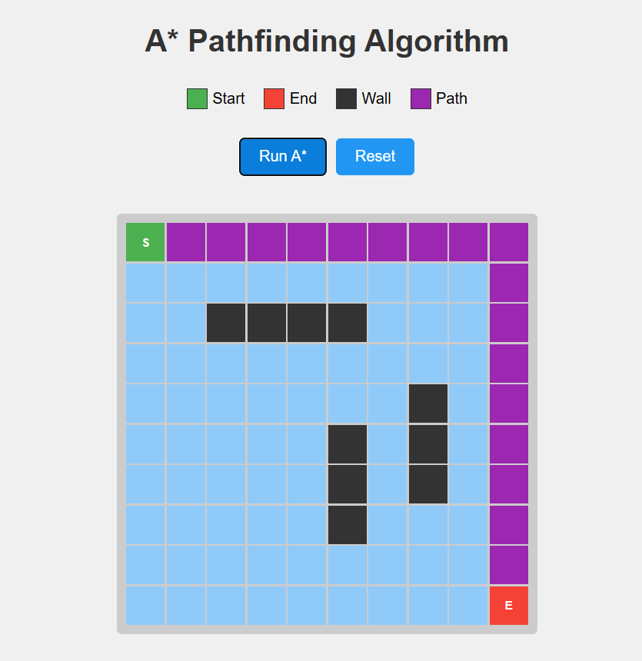

EXPLAINATION:
A* Formula: f(n) = g(n) + h(n)
- g(n) = cost from start to current node
- h(n) = heuristic (estimated cost to goal) - Manhattan distance
- f(n) = total estimated cost

Steps:
- Add start node to open list
- While open list not empty:
  - Pick node with lowest f value
  - If it's the goal → done
  - Move to closed list
  - Check all neighbors
  - Calculate f, g, h for each
  - Add to open list if better path found
- Backtrack from goal to start using parent pointers

